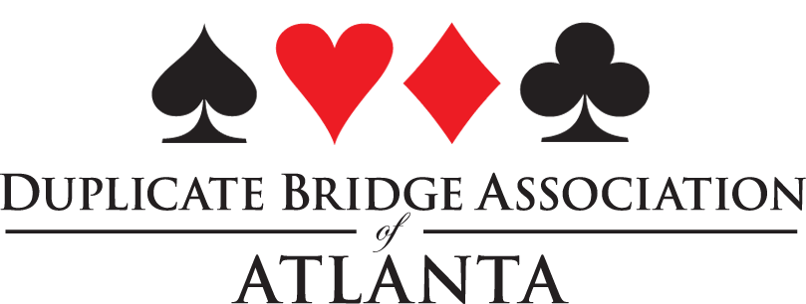Approved

DBAA/ Unit 253 Board Meeting
January 8, 2021 4:00 pm via Zoom

Officers: Marty Nathan, Linda Hagood, Barbara Fleming, Denise DeAngelo,
Unit Reps: Becky Butler, John Simms, Melissa Taylor, Sue Williams,
Guests: Judy Fendrick

Marty Nathan called the meeting to order.
Old Business
Denise DeAngelo made a motion to approve the minutes of the last 2 board meetings, which included the annual meeting held last February at the Regional Tournament and a special meeting held via zoom on May 11, 2020. The motion passed.
Barbara Fleming presented a summary of the Treasurers report as follows:
$45,947 in the bank
$279, 613 of investments
$325,809 total
$5800 profit this year
New Business
Judy Fendrick spoke to the board about the nominations for District 7 Goodwill Committee. The nominations this year were Jane Melby, Richard Siegel and Diane Strickland. Voting for Goodwill Committee appointment is usually done by secret ballot, but because of COVID restrictions, Marty Nathan asked if there were any objections to a voice vote during the zoom meeting. All board members present agreed to a voice vote. Congratulations to Jane Melby and Diane Strickland on their appointment to the Goodwill Committee.
Barbara Fleming must resign as treasurer of the DBAA for personal reasons. The DBAA bylaws provide that the president may appoint a replacement, subject to approval of the board. Marty Nathan offered to fill in as acting treasurer until the position was filled. The board decided to discuss candidates and vote via email to fill the treasurer's position. Thank you to the new treasurer of the DBAA, Jane Melby, who was unanimously approved by the board.
The meeting was adjourned.

Respectfully submitted,

Denise DeAngelo, Secretary DBAA

